SCHEMA AND E-R DIAGRAM

Raghavi H Gaonkar
4AL17CS071

1. Consider the following relations:
Student (snum: integer, sname: string, major: string, level: string,age: integer)
Class (name: string, meets at: string, room: string, d: integer)
Enrolled (snum: integer, cname: string)
Faculty (fid: integer, fname: string, deptid: integer)

Schema Diagram:

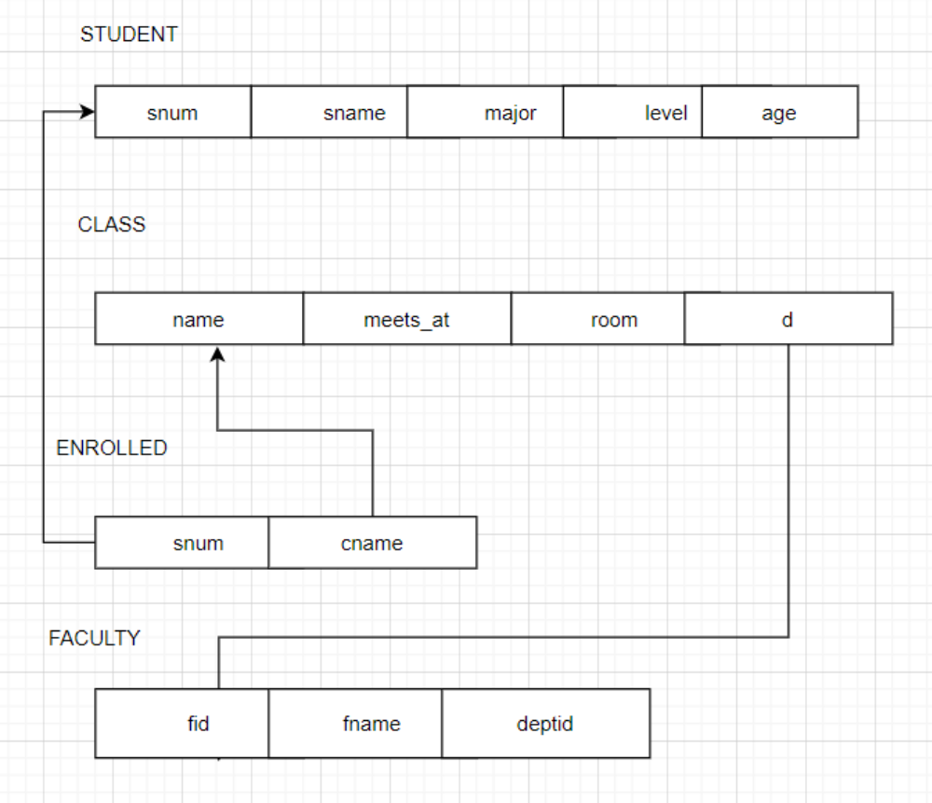

E-R Diagram:

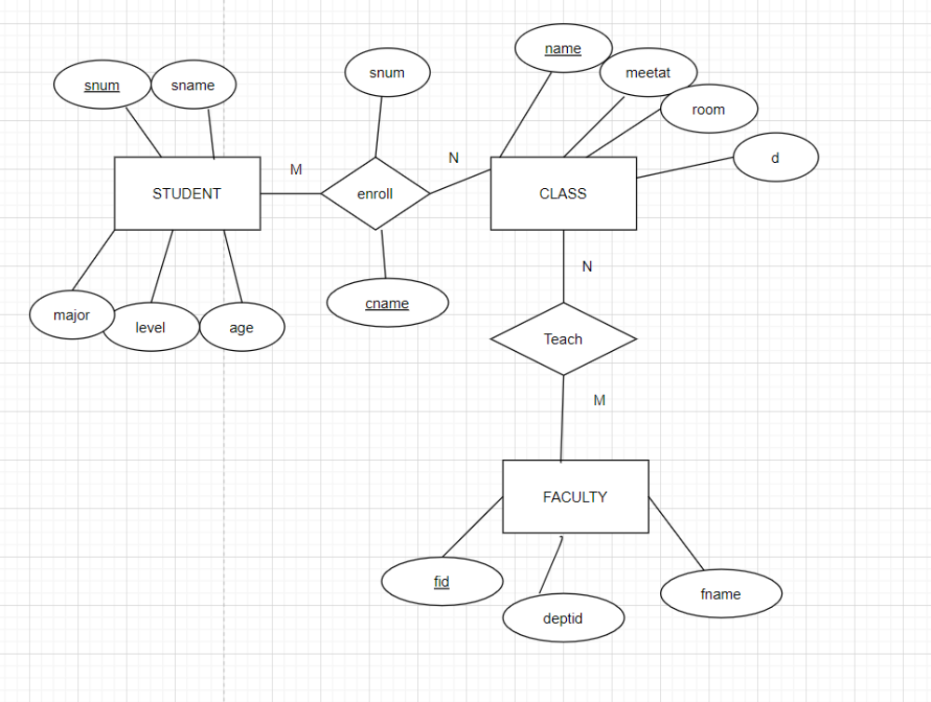

2.Consider the following database for a banking enterprise
BRANCH(branch-name:string,branch-city:string,assets:real) ACCOUNT(accno:int,branch-name:string,balance:real) DEPOSITOR(customer-name:string,accno:int)
CUSTOMER(customer-name:string,customer-street:string,city:string) LOAN(loan-number:int,branch-name:string,loan-number-int) BORROWER(customer-name:string,customer-street:string,city:string)

Schema Diagram:

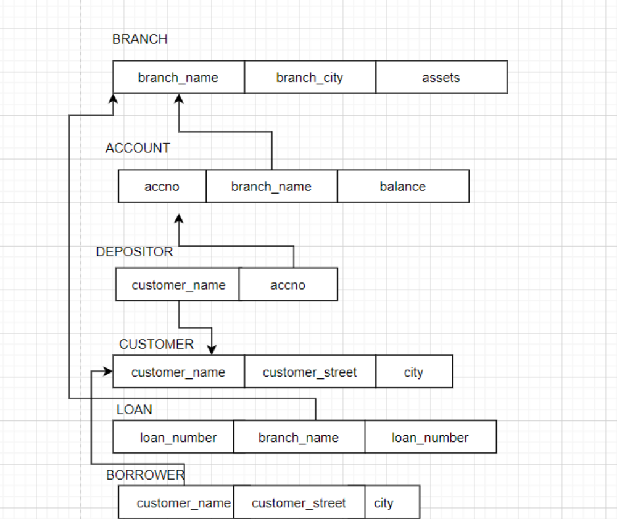

E-R Diagram:

